LiveCase

Briefing Questionnaire
Step 1: Define the scope
Learning objectives?

Tools/frameworks/skills?

Audience level & experience?

Duration?

Team or solo?

Synchronous or
asynchronous?

Step 2: Sketch the story
Real or fictional?

Context / setting?

Hero? (Learner role)

Core challenge / task?

Tasks along the way?

Assessment? (Points)

Characteristics? (Evaluation metrics in addition to points)

Structure?

Step 3: Create the context
LiveCase Context |  | Supporting asset:
Startups / Corporate Innovation Projects |  | Supporting asset:
Key virtual characters (aim for diversity) |  | Supporting asset:

Step 4: Define the teaching, tools and tasks
Task 1  [...] | Teaching & tools  Task:  - . |  | Supporting assets:

Step 5: Block out each episode, element by element
Content type | Character | Chat |  | Optional Media
[...] | [...] | [...] |  | [...]

Step 6: Start writing! :-)
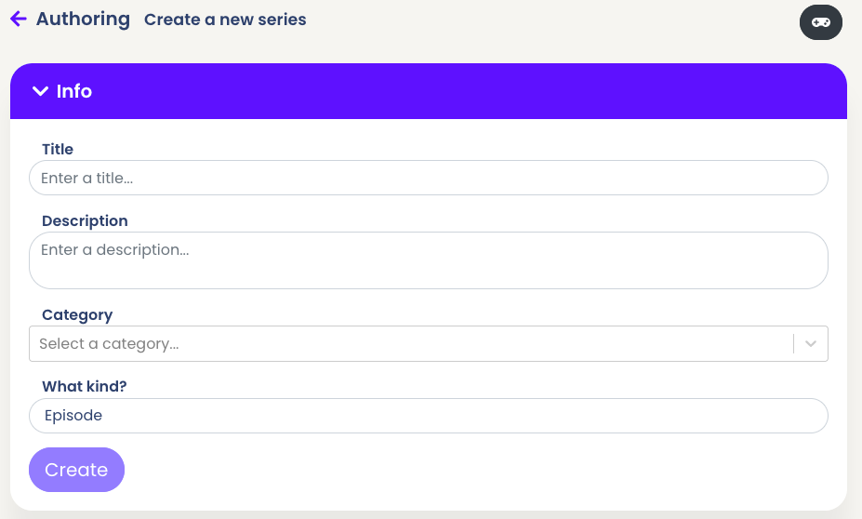

Step 5: Block out each episode, element by element

